sudo dpkg -i cuda-repo-ubuntu1604_9.0.176-1_amd64.deb
출처: https://goodtogreate.tistory.com/entry/TensorFlow-GPU-버전-우분투-1604에-설치-하기 [GOOD to GREAT]
sudo apt-key adv --fetch-keys http://developer.download.nvidia.com/compute/cuda/repos/ubuntu1604/x86_64/7fa2af80.pub
출처: https://goodtogreate.tistory.com/entry/TensorFlow-GPU-버전-우분투-1604에-설치-하기 [GOOD to GREAT]

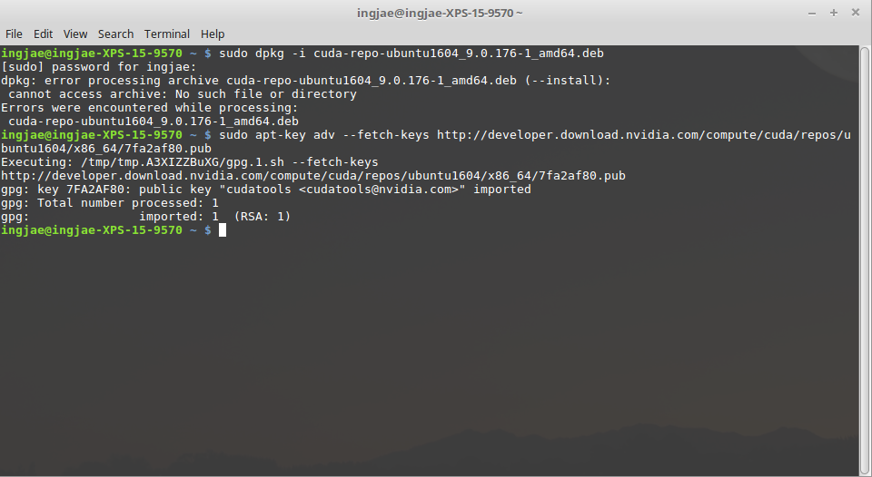
sudo apt-get install cuda-9-0

https://www.popit.kr/tensorflow-install-ubuntu16/

0 3D controller: NVIDIA Corporation GP107M [GeForce GTX 1050 Ti Mobile] (rev a1)
Subsystem: Dell Device 087c
Kernel driver in use: nvidia
Kernel modules: nvidiafb, nouveau

http://www.kwangsiklee.com/2017/07/%EC%9A%B0%EB%B6%84%ED%88%AC-16-04%EC%97%90%EC%84%9C-cuda-%EC%84%B1%EA%B3%B5%EC%A0%81%EC%9C%BC%EB%A1%9C-%EC%84%A4%EC%B9%98%ED%95%98%EA%B8%B0/

쿠다 10.1설치
위에 꺼 처럼
run파일을 받아
sudo./ 시킨뒤 그대로 따라하기

